Home



About

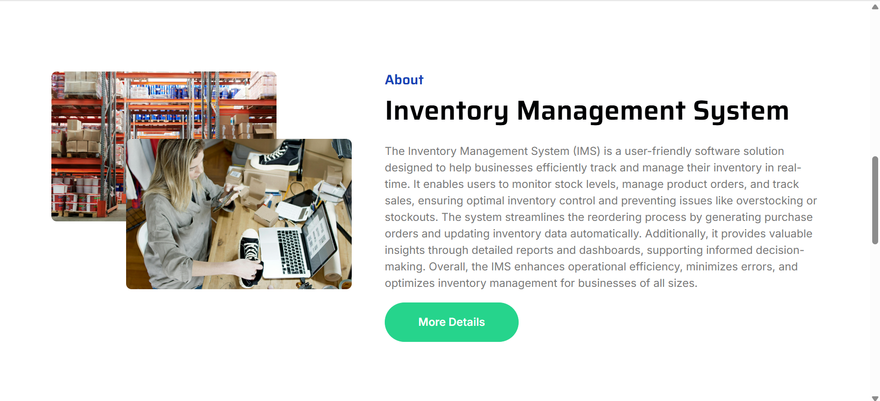

Companies

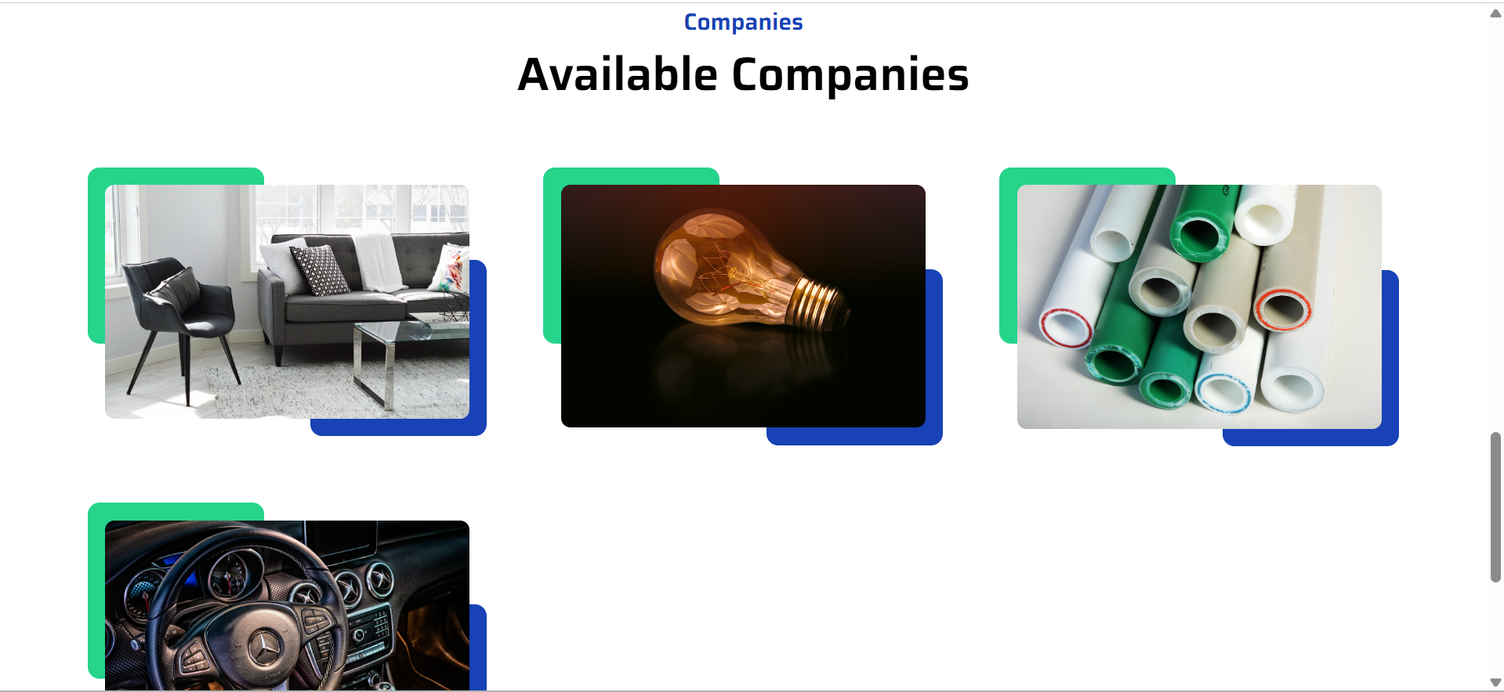

Company Registration

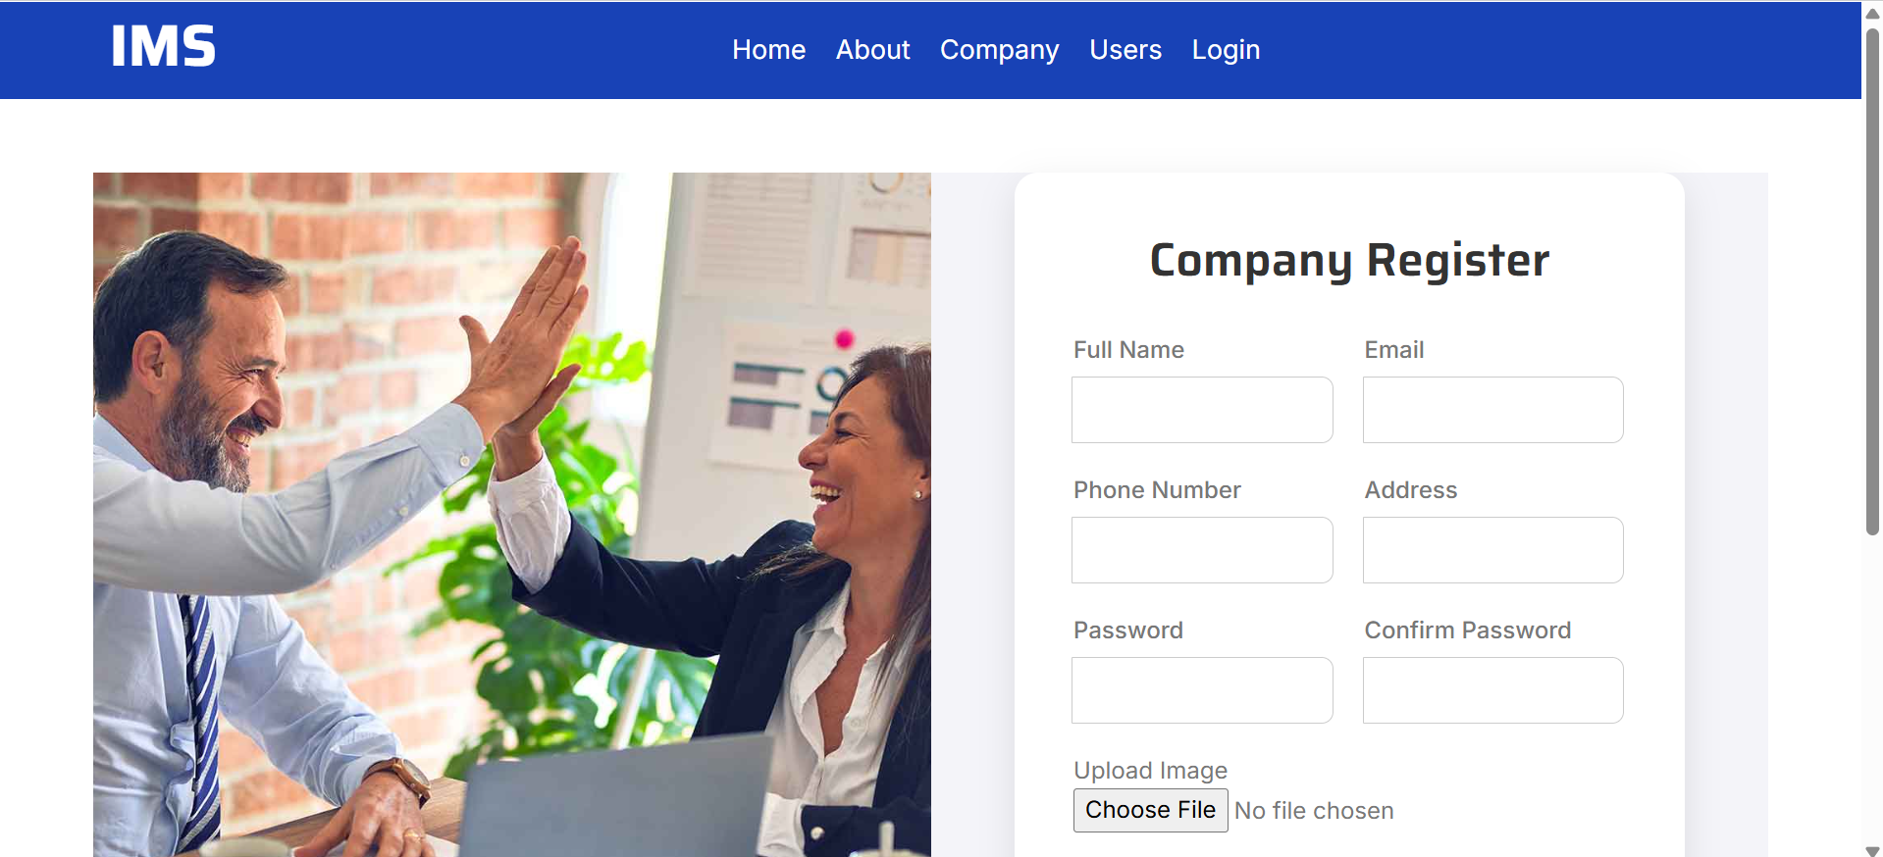

User Registration

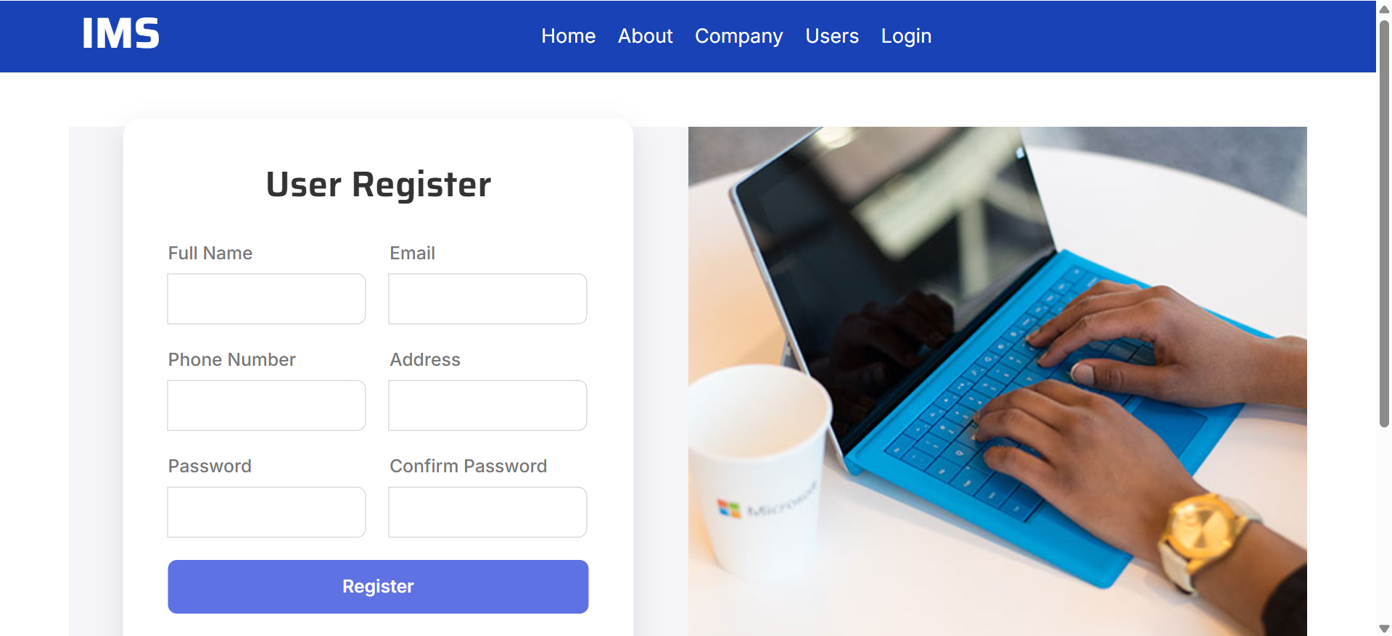

Login

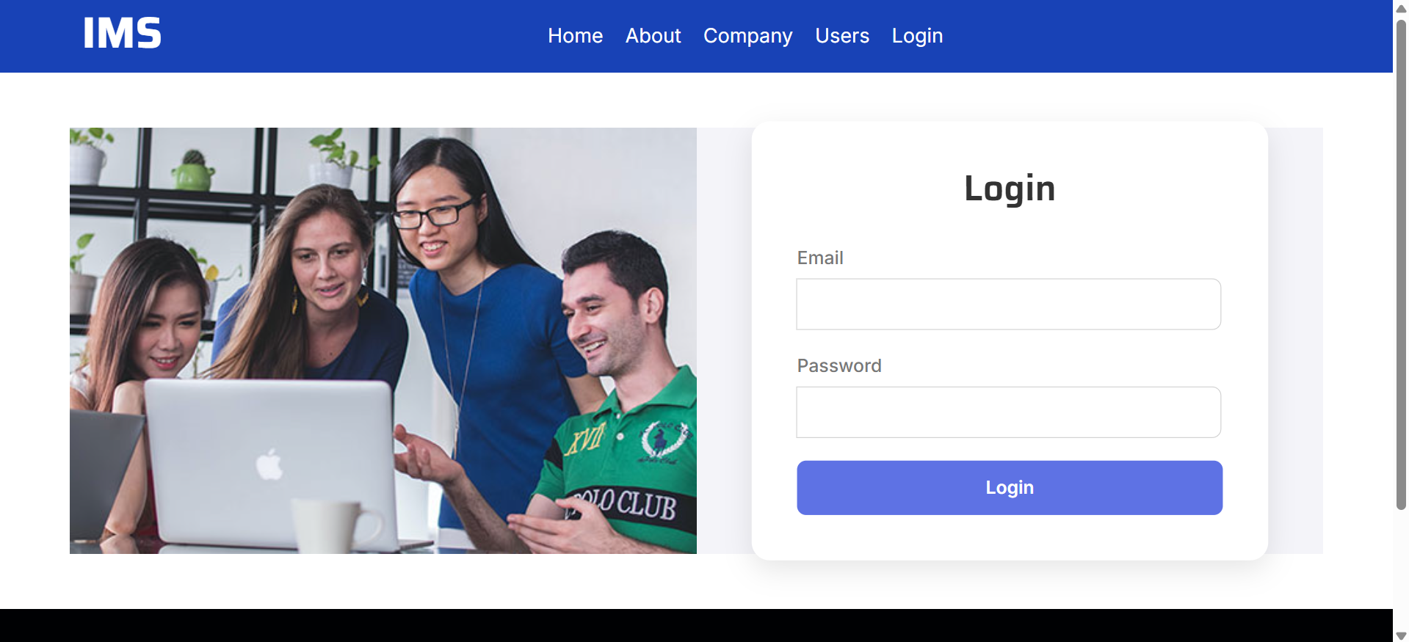

After Company Login



Add Products

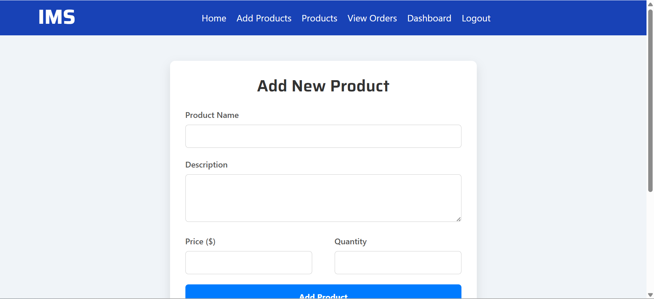

Manage Products

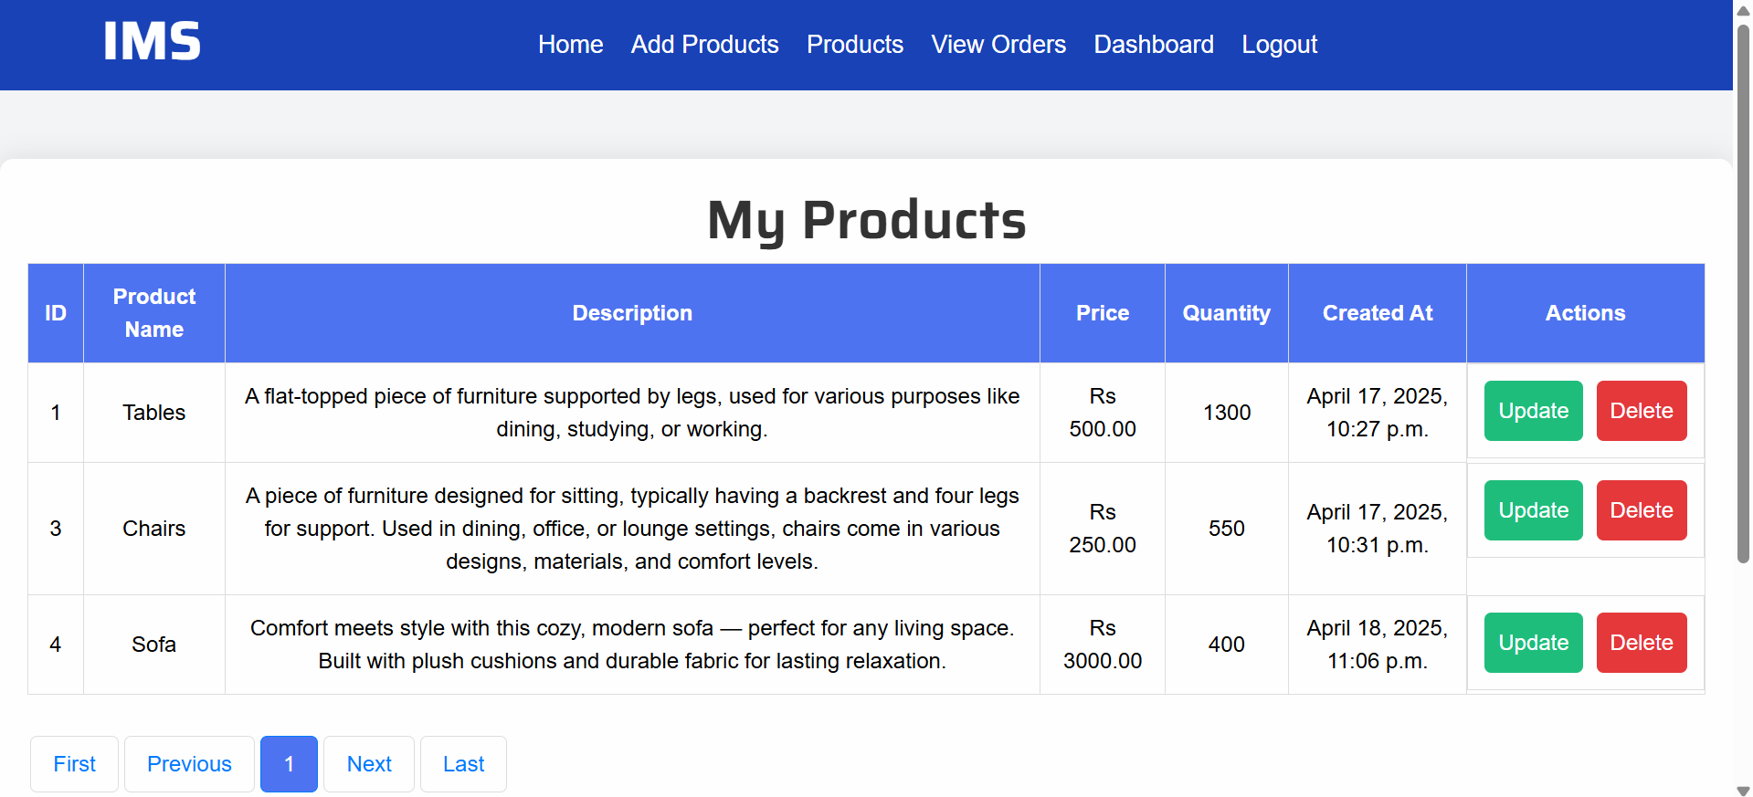

Manage Orders

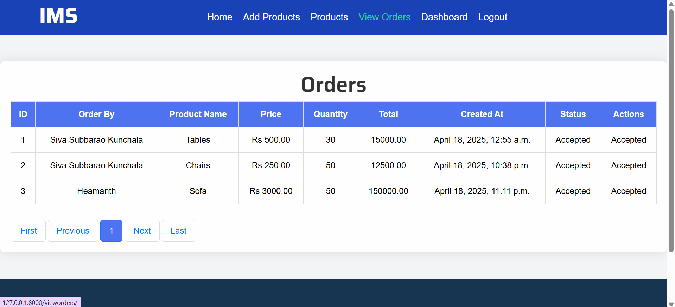

Dashboard

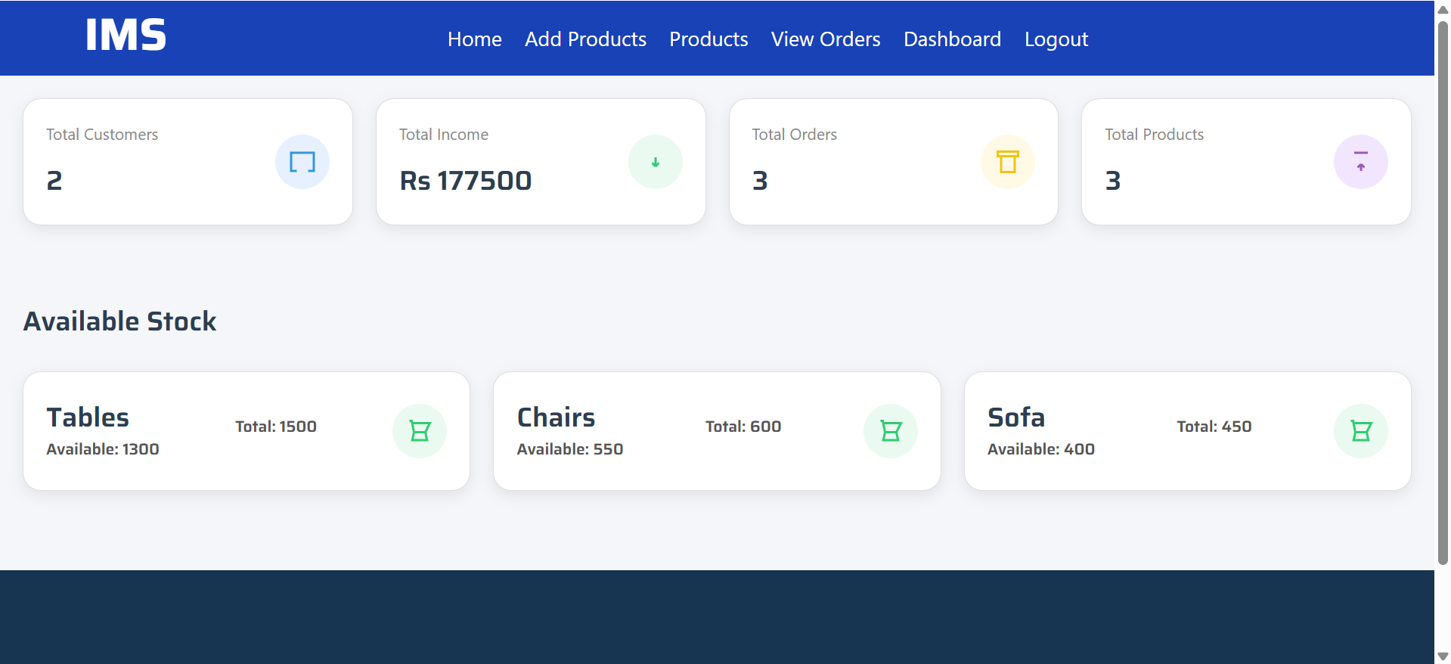

After User Login



Companies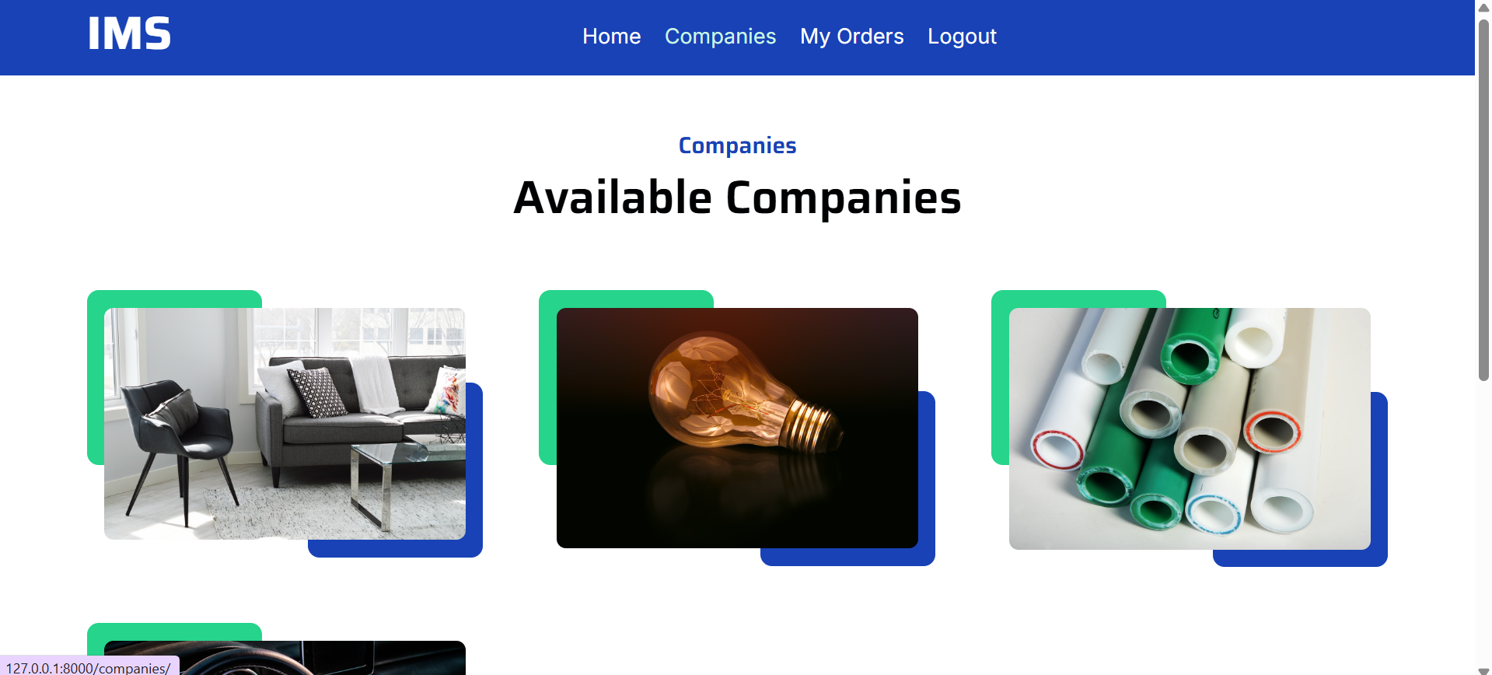

View Products

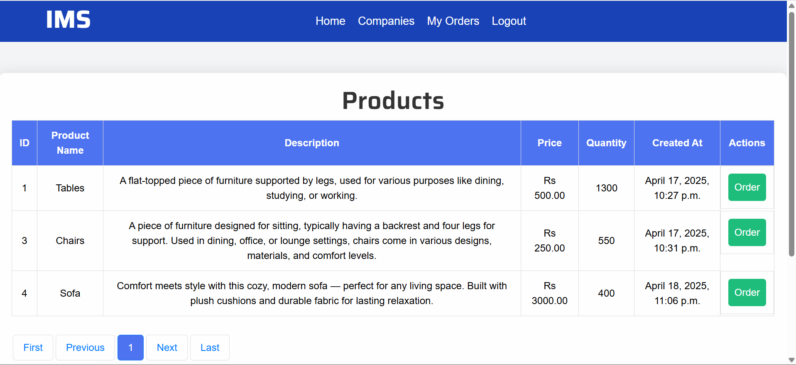

Order Products

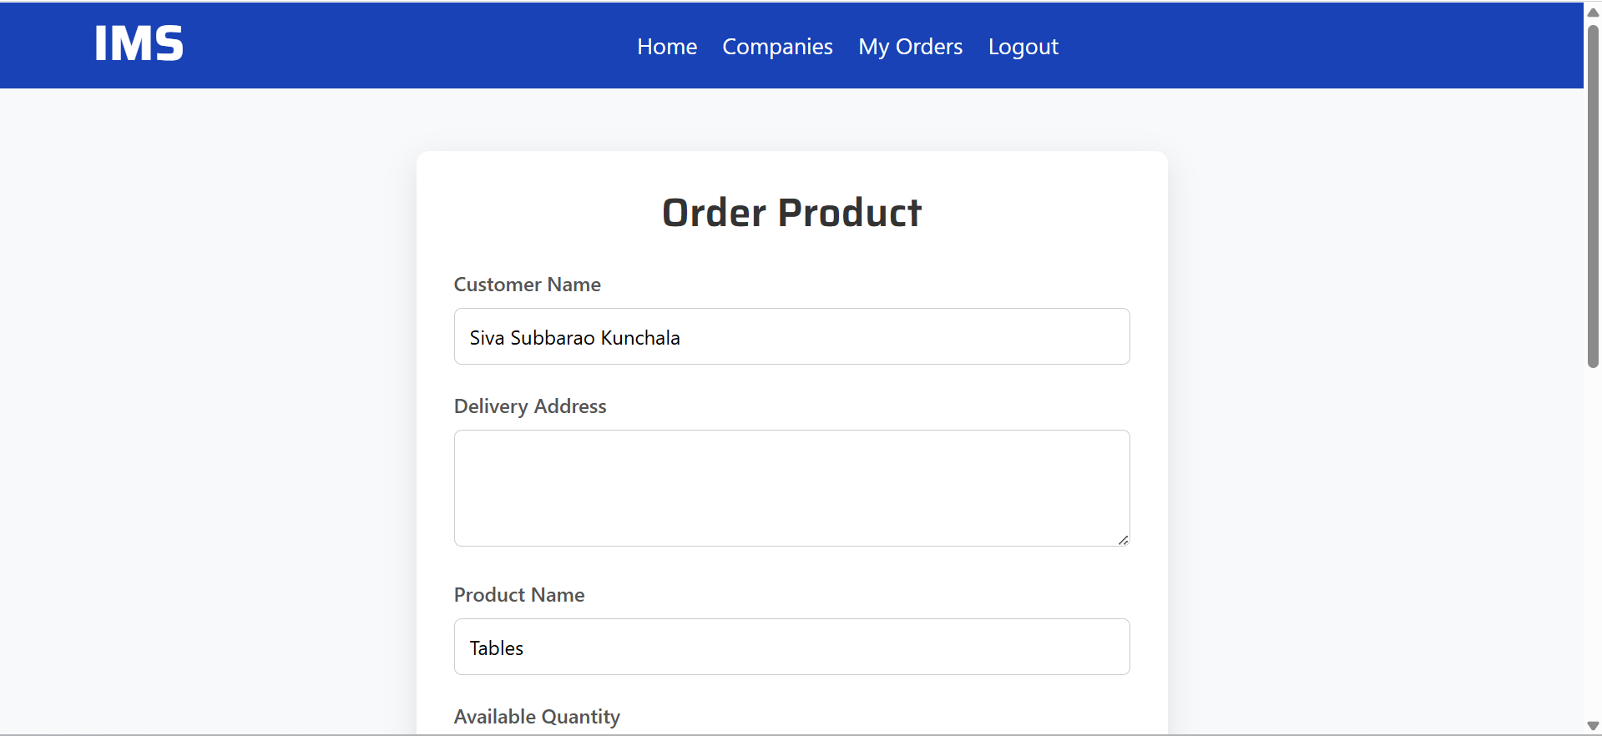

My Orders

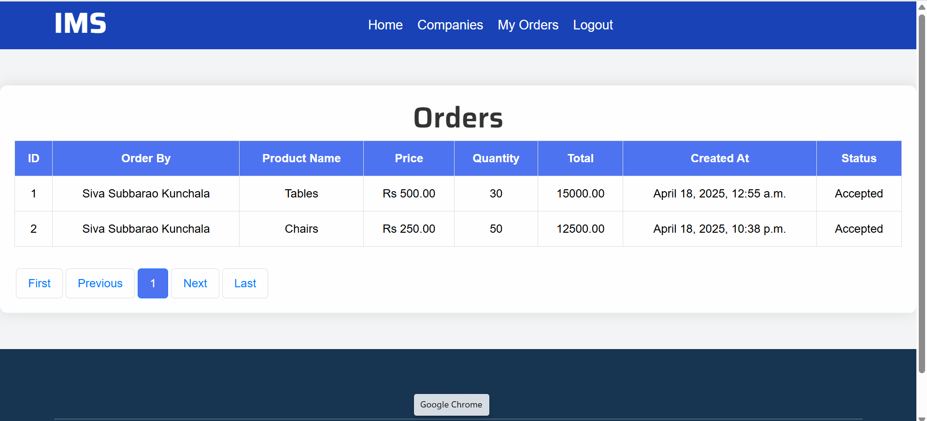

Companies Table



Users Tables



Products Table





Orders Table





Models

from django.db import models

import os

class UserModel(models.Model):

full_name = models.CharField(max_length=100)

email = models.EmailField(unique=True)

phone = models.CharField(max_length=15)

address = models.TextField()

password = models.CharField(max_length=128)

def __str__(self):

return self.full_name

class Meta:

db_table = 'UserModel'

class Company(models.Model):

full_name = models.CharField(max_length=100)

email = models.EmailField(unique=True)

phone = models.CharField(max_length=15)

address = models.TextField()

password = models.CharField(max_length=128)

created_at = models.DateTimeField(auto_now_add=True, null=True)

profile = models.FileField(upload_to=os.path.join('static', 'Company_Profiles'), null=True)

def __str__(self):

return self.full_name

class Meta:

db_table = 'Company'

class Products(models.Model):

name = models.CharField(max_length=100)

price = models.DecimalField(max_digits=10, decimal_places=2)

description = models.TextField()

company = models.ForeignKey(Company, on_delete=models.CASCADE)

created_at = models.DateTimeField(auto_now_add=True, null=True)

quantity = models.IntegerField()

total_qty = models.IntegerField(null=True)

def __str__(self):

return self.name

class Meta:

db_table = 'Products'

class Orders(models.Model):

customer = models.ForeignKey(UserModel, on_delete=models.CASCADE)

product = models.ForeignKey(Products, on_delete=models.CASCADE)

address = models.TextField()

order_date = models.DateTimeField(auto_now_add=True)

status = models.CharField(max_length=100, default='pending')

ord_qty = models.IntegerField()

total_price = models.DecimalField(max_digits=10, decimal_places=2)

def __str__(self):

return self.customer.full_name

class Meta:

db_table = 'Orders'